**ASSOC**

The batch command ASSOC associates a file extension with a file type, or list all associations.

**Example**

@echo OFF

ASSOC | find ".txt"

pause

**Output**

.txt = textfile

As shown in above output, it displays the file association for .txt extension.

If only ASSOC is written and executed, it will display all the file associations for every extension, instead of just .txt extension.

**ATTRIB**

The batch command ATTRIB is used to display the [file attributes](https://en.wikipedia.org/wiki/File_attribute) or set an attribute to a file in the working directory.

**Example**

Now let us suppose we have a file note.txt in our working directory. We will display its file attributes and then make it hidden and read only by adding 'ah' and 'r' attributes to it. And finally, we will remove some attributes we added as well.

@echo OFF

:: To display attribute of note.txt

ATTRIB note.txt

:: To make it read only by adding 'r'

ATTRIB +r note.txt

ATTRIB note.txt

:: To make it hidden by adding 'ah'

ATTRIB +ah note.txt

ATTRIB note.txt

:: To remove attribute read only

ATTRIB -r note.txt

ATTRIB note.txt

**Output**

A note.txt

A R note.txt

A R AH note.txt

A AH note.txt

Here in this output, A means *Archived*, R means *Read only* and AH means *Hidden* file.

**CD**

The batch command CD helps in navigating through different directories and changing directories or displaying current directory.

**Example**

@echo OFF

:: CD without any parameters displays the current working directory

CD

:: Changing to the parent directory one level up

CD..

CD

:: Changing the path to Programs

CD\Programs

CD

pause

**Output**

C:\Users\abc

C:\Users

C:\Programs

**CHKDSK**

The batch command CHKDSK is used for checking error in the disk.

**Example**

@echo OFF

CHKDSK

**CHOICE**

The batch command CHOICE provides a list of options to the user.

**Example**

@echo OFF

ECHO You want coffee?

ECHO Enter Y for yes

ECHO Enter N for no

CHOICE /c YN /m "Yes or No"

**Output**

Now that script will produce following output.

You want coffee?

Enter Y for yes

Enter N for no

Yes or No [Y,N]?

Now the console waits for your input and once you enter your answer it will terminate.

**CLS**

The batch command CLS clears the screen.

**Example**

@echo OFF

CLS

pause

This command just clears all the logs in command prompt screen.

**CMD**

The batch command CMD invokes a new command prompt window.

**Example**

@echo OFF

CMD

**COMP**

The batch command COMP compares the size of two files and checks if they are different in size.

**Example**

@echo OFF

COMP C:\abc.txt C:\xyz.txt

**CONVERT**

The batch command CONVERTS the volumes or drives from one format to another i.e from FAT to NTFS.

**Example**

@echo OFF

CONVERT D:\

**COPY**

The batch command COPY is used for copying files from one location to another.

**Example**

@echo OFF

:: For copying from one drive to another -xyz.txt from D:\ to E:\

COPY D:\xyz.txt E:\

:: If file has whitepace between name - use double quote

COPY "D:\my file.txt" E:\

**DATE**

The batch command DATE displays the current date in the system.

**Example**

@echo OFF

echo %DATE%

**Output**

Fri 07/07/2017

This command DATE displays system date in command prompt as shown above.

**DEL**

The batch command DEL is used for deleting files.

**Example**

@echo OFF

:: To delete a single file xyz.txt

DEL D:\xyz.txt

:: To delete all the files of .txt extensions and ask for confirmation before deleting

DEL /p/s D:\*.txt

:: Remove \p to delete without confirmation

DEL /s D:\*.txt

**Note:** DEL command only deletes files, not directories.

**DIR**

The batch command DIR lists all the contents of directories.

**Example**

@echo OFF

:: To list all the contents of current directory

DIR

:: To list all the hidden files of working directory

DIR /ah

:: To list all files with .php extensions

DIR *.php

**DISKPART**

The batch command DISKPART shows the properties of a disk partition.

**Example**

@echo OFF

DISKPART

This script will ask for users permission to check the properties of disk partition and if allowed, will display following output in the console depending on disk properties.

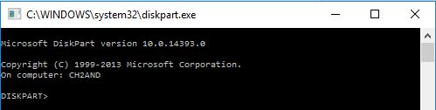

**DRIVERQUERY**

The batch command DRIVERQUERY displays all the drivers installed and their properties.

**Example**

@echo OFF

DRIVERQUERY

**Output**

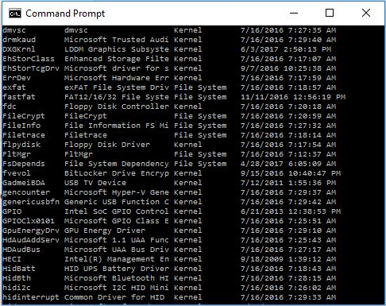

This output shows the fraction of drivers list with their properties and installed date. DRIVERQUERY command shows all the drivers list, which is huge.